

**Hardware Schematics**

**Group 09**

**Group Members:-**

**Abhishek Ravi**

**Ravi Theja Reddy Singannagari**

**Sai Ganesh**

**Saran Kumar Krishnasamy**

**Vaghul Aditya Balaji**

**Venkatesh Sridhar**

**Introduction:-**

The hardware aspect of our project comprises of two motherboards (one for the Cash Register System and one for the Price Display System). Part I of this project includes the two boards, which Part II comprises of a Speaker System (which includes a voice synthesizer without using dedicated voice synthesizer chips), a total of eight 7-Segment Displays on the Cash Register System which are used for displaying both the price of the items as well as the barcode, an LCD display on the Price Display System for displaying the name and price of items and two Keypads on the Cash Register System for getting input from the user. On both the motherboards, the main driver is the 80188 chip and all the processing revolves around it. The 80188 chip interacts with peripheral devices through the Intel 8255 chip.

**Cash Register System:-**

As stated above, we are using the Intel 8255 chip to interact with the peripheral devices using the three sets of I/O pins present on the chip (Port A, Port B and Port C). The Cash Register System comprises of the eight 7-Segment Displays, the speaker system and the two Keypads. We are configuring the ports in such a way that, Port A and Port B are used as Output Ports while Port C is used as an input port. This can be configured on the CWR register. Port A is mainly used for interfacing with the eight 7-Segment Displays while Port B and Port C are used for interfacing with the Keypad. For interfacing with the speaker system which includes a voice synthesizer, we are using the internal pins present on the 80188 chip.

* **7-Segment Displays:-**

The eight 7-segment displays are interfaced with Port A of the 8255 chip through a 7447 BCD-7 segment decoder and a 74137 3-8 Decoder. Pins 0-2 of Port A are connected to the 3-8 Decoder while, Pin 3 is used to enable/disable output from the 3-8 Decoder and Pins 4-7 are connected to the 7447 Decoder. The 7-segment displays are assumed to be of common cathode type. Initially, when the service of the 7-segment displays are needed, the program sends what digit has to be displayed through the 7447 decoder interfaced with the 8255 chip. The output of this 7447 decoder is then sent simultaneously to all the eight 7-segment displays. Since the current which travels through this connection is split-up amongst the 7-segment displays, we are using NPN-transistors as amplifiers to amplify the voltage that travels through these connections. Moreover, we are using resistors to control the current which flows into the 7-segment displays. In order to control which 7-segment display is used for the display, we are using the 3-8 decoder. The 8 output lines of the decoder are connected to each of the 7-Segment Displays such that depending on which display we want to use, we activate the corresponding pin through the 3-8 decoder. Since the 7-Segment displays we use are common cathode in nature, we have to invert the control signals which we send to each of the displays from the 3-8 decoder. Thus we have used two SN1404 chips for this purpose. However, in case we want nothing to be displayed, we use pin 4 of Port A to send a signal to one of the control pins of the 3-8 decoder such that none of the 7-segment displays are used. The above description can be inferred from the following schematic.

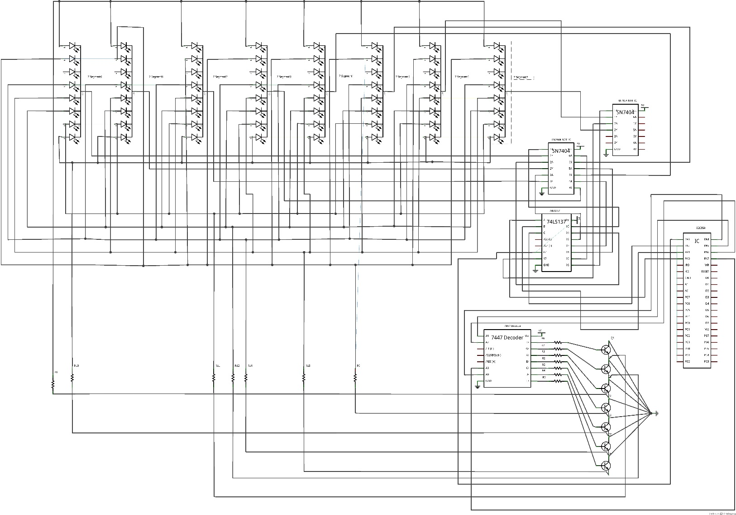

* **Keypads:-**

The two keypads are interfaced with the motherboard through Port B and Port C of the 8255 chip. We have configured Port B to be for used for output and Port C for input. Pins 4-7 of port B are used to send the necessary output signals to both the keypads at the same time. This is used to access the 4*3 keypads row-wise. In order to see which key is being pressed on the keypads, we are getting back the signals column-wise with the help of the remaining 3 pins which are used to interface with the keypad. This is taken care of by Port C. Pins 2-7 (Pins 2-4 for Keypad 1 and Pins 5-7 for Keypad 2) are used to receive input from both the keypads and then we determine which key is being pressed in the ASM program. The above can be inferred from the following circuit-schematic.

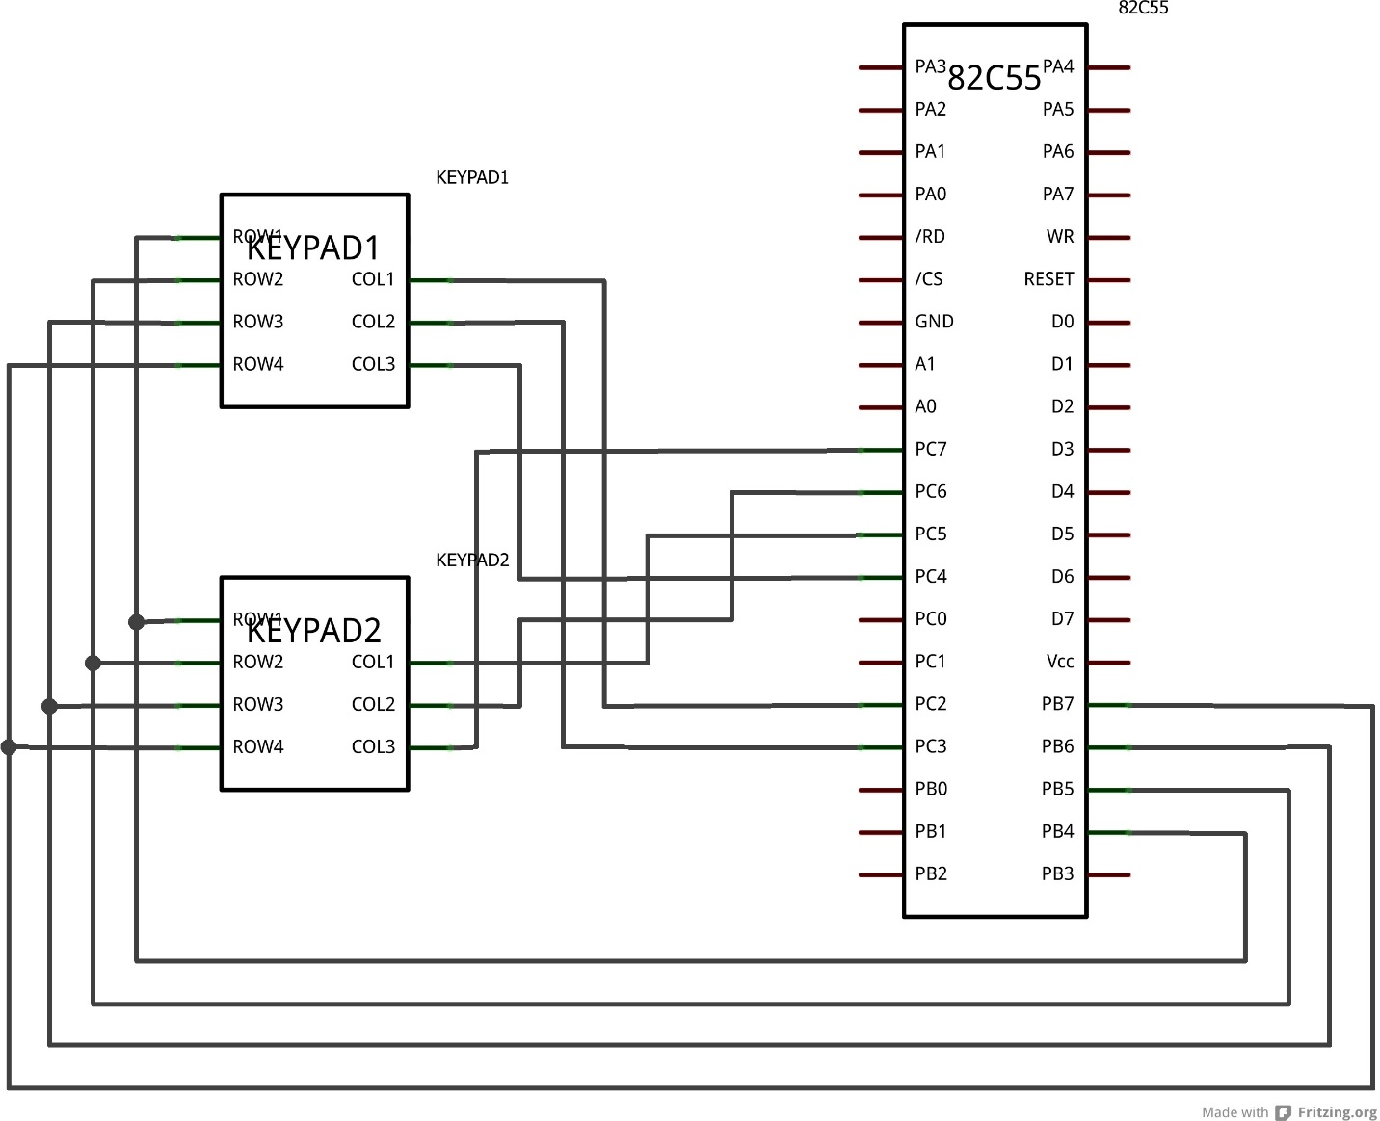

* **Speaker System:-**

The speaker interfaced with the 80188 processor is used for playing audio files from the EEPROM. We use the micro-processors MCS0-MCS3 pins to enable the EEPROM. Then the address for the audio files travels through the latch to the ROM to retrieve the files. Also, to enable the DAC, we use the micro processor's Peripheral select pin and send it to the chip select of the DAC. Other control pins in the DAC are activated accordingly. The Vref in the DAC can be tuned using the potentiometer to derive the best output from the speaker. Moreover to improve the audio, the amplification gain can be tuned using the capacitor-resistor circuit used to connect pins 1 and 8 of LM386 in order to get the best possible sound. Finally the speaker is connected to a decoupling capacitor. The above can be inferred from the following schematic.

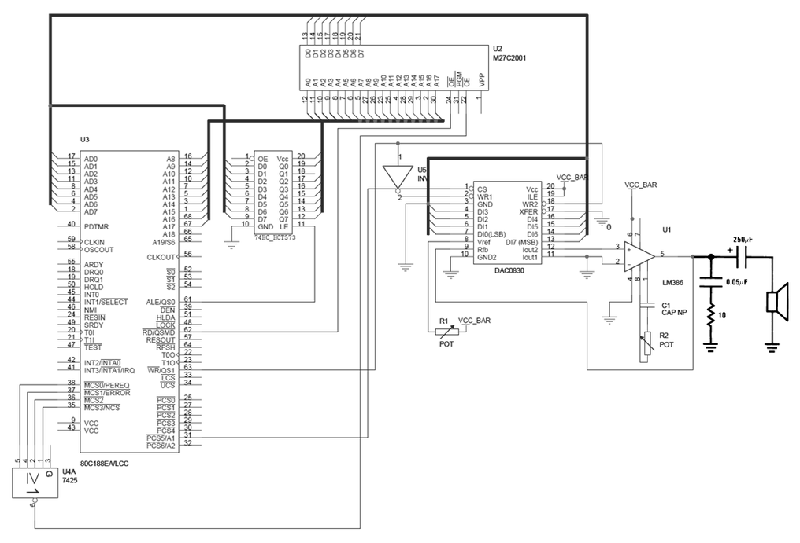k

**Price Display System:-**

Similar to the cash register system, we are using the 8255 chip to interact with the peripheral devices using the three sets of I/O pins present on the chip. As far as the basic requirements are concerned, we will be connecting a single 16*2 LCD display to the motherboard.

* **LCD Display:-**

For interfacing the LCD system with the board, we are making use of Port B and Port C. Port A is left unused as of now while both Port B and Port C are configured to be used as output ports. The eight pins of Port B are connected to the 8 data bits on the LCD system while pins 0-3 of Port C are used for controlling different aspects of the system. The above can be inferred from the following schematic.

